* **Main Task**
* **Note -**

1. Not able to deploy webpage using Amazon Elastic Cloud.
2. Not able to store data in Relational Database using AWS Services.

(But I know the steps and how to implement it)

* All 8 questions are solved by me with proper steps and practical.

**Why?** I am using AWS student account and account is provided by college for educational purpose, so I have limited permissions and some restrictions, there in insufficient permissions while deploying webpage in EC2 and storing and connecting data in RDS.

**What I Did?** I used S3 service and put website/html file in Bucket and give necessary permissions to host that website publically

I used RDS service for storing database and trying to connect it with MySQL server

Steps taken by me are as follows –

**Process to store data in Relational Database using AWS Service RDS with the help of MySQL**

Step 1 – Login to AWS and choose Module 10 Databases and Lab 10 RDS

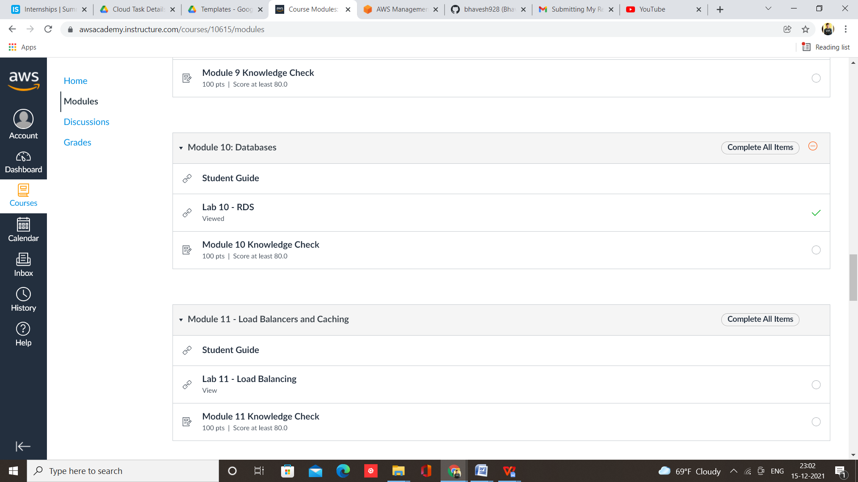

Step 2 – Start Lab and Open AWS console

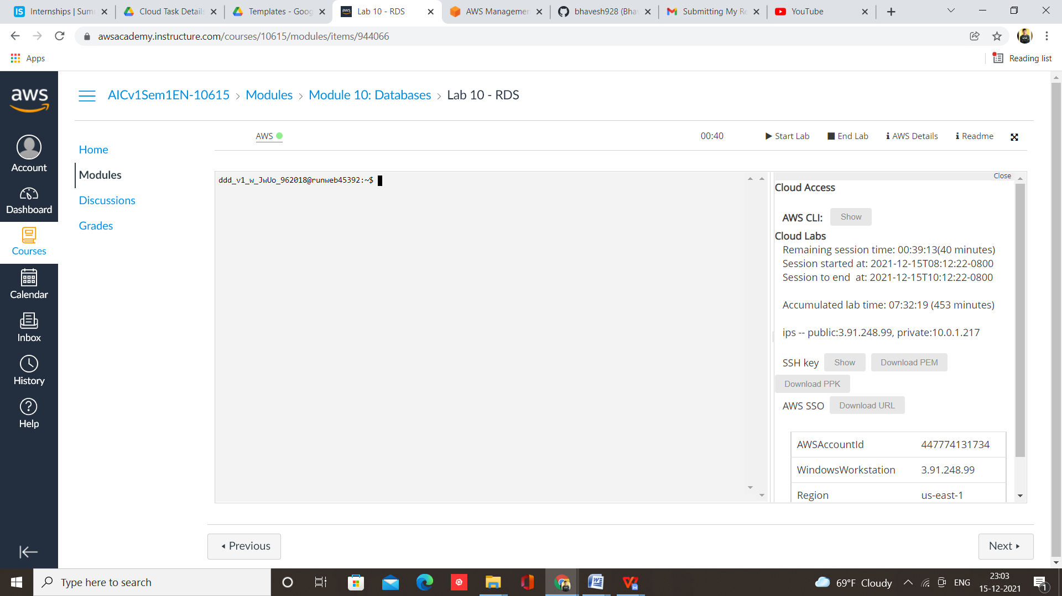

Step 3 – Select RDS from services

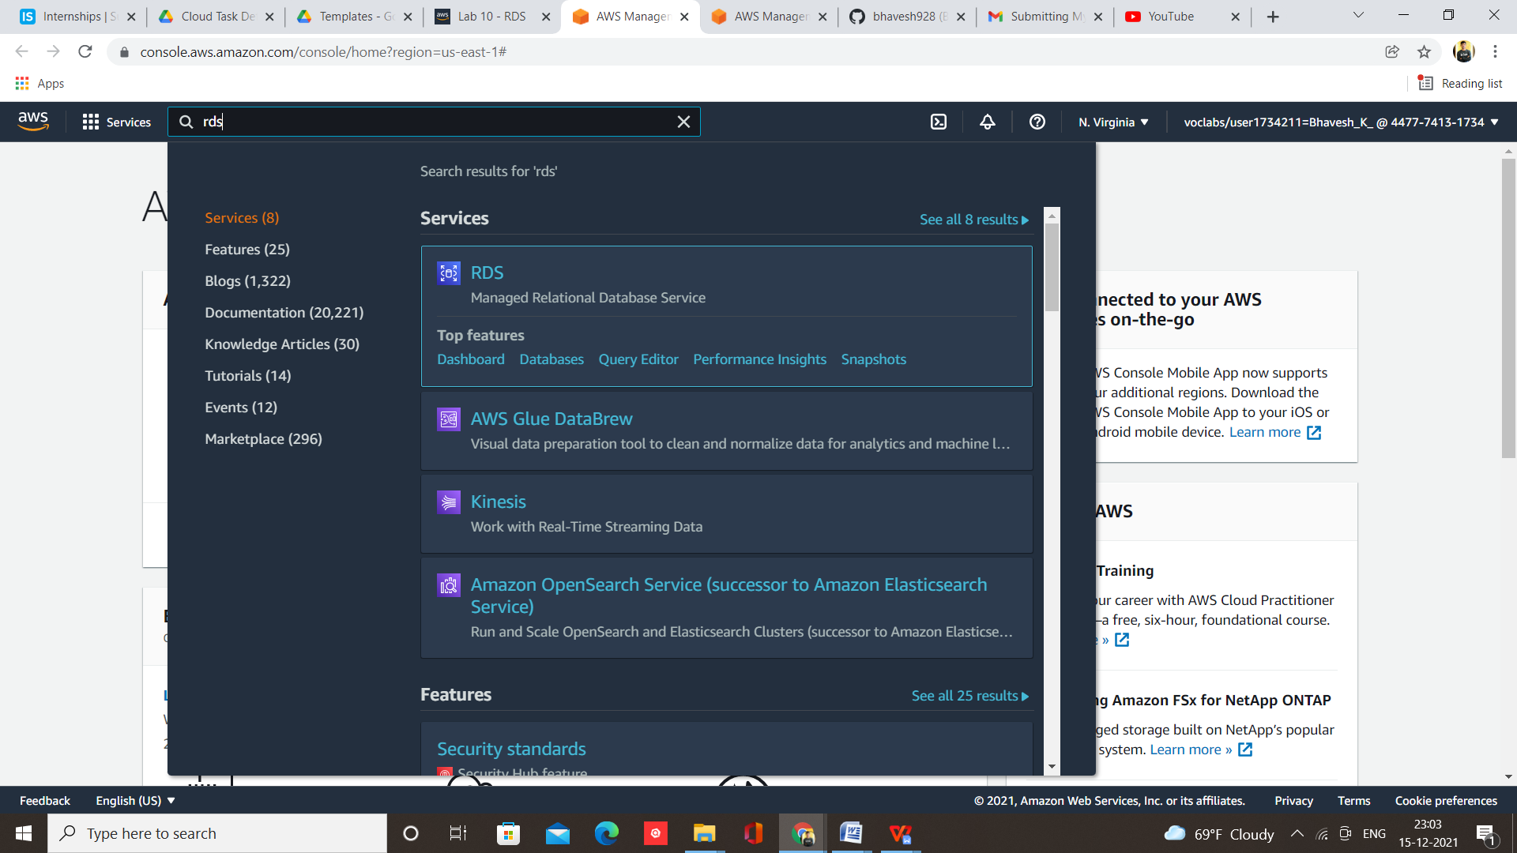

Step 4 – Click on Create Database

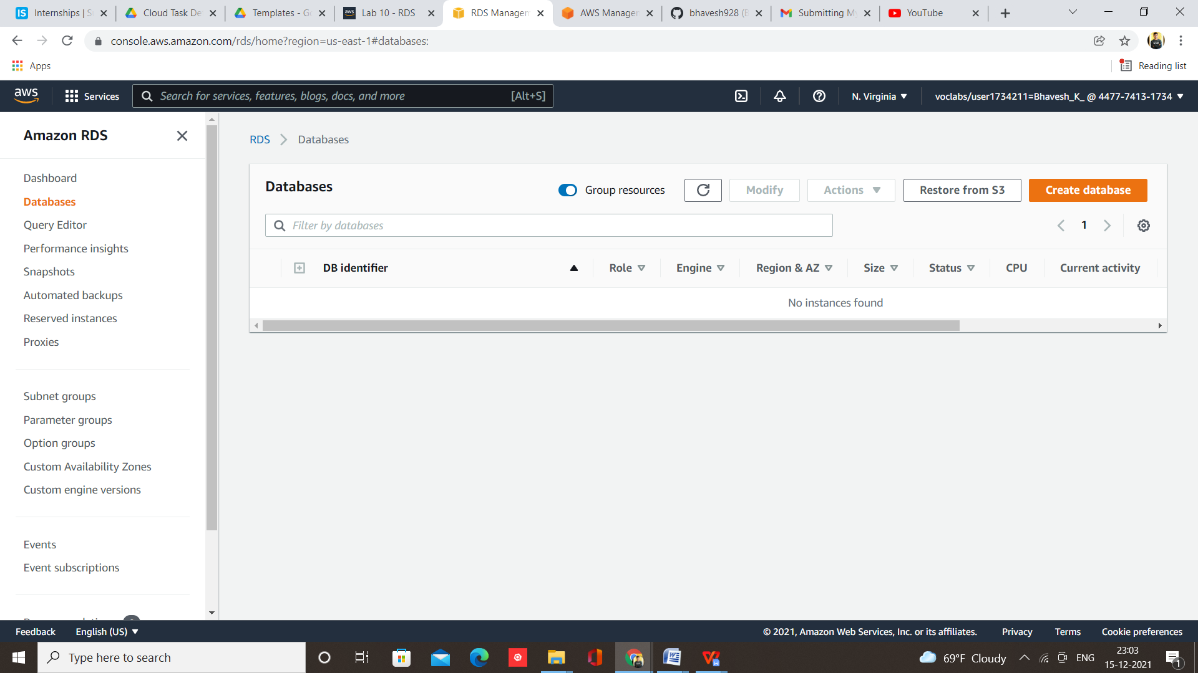

Step 5 – Select MySQL Engine

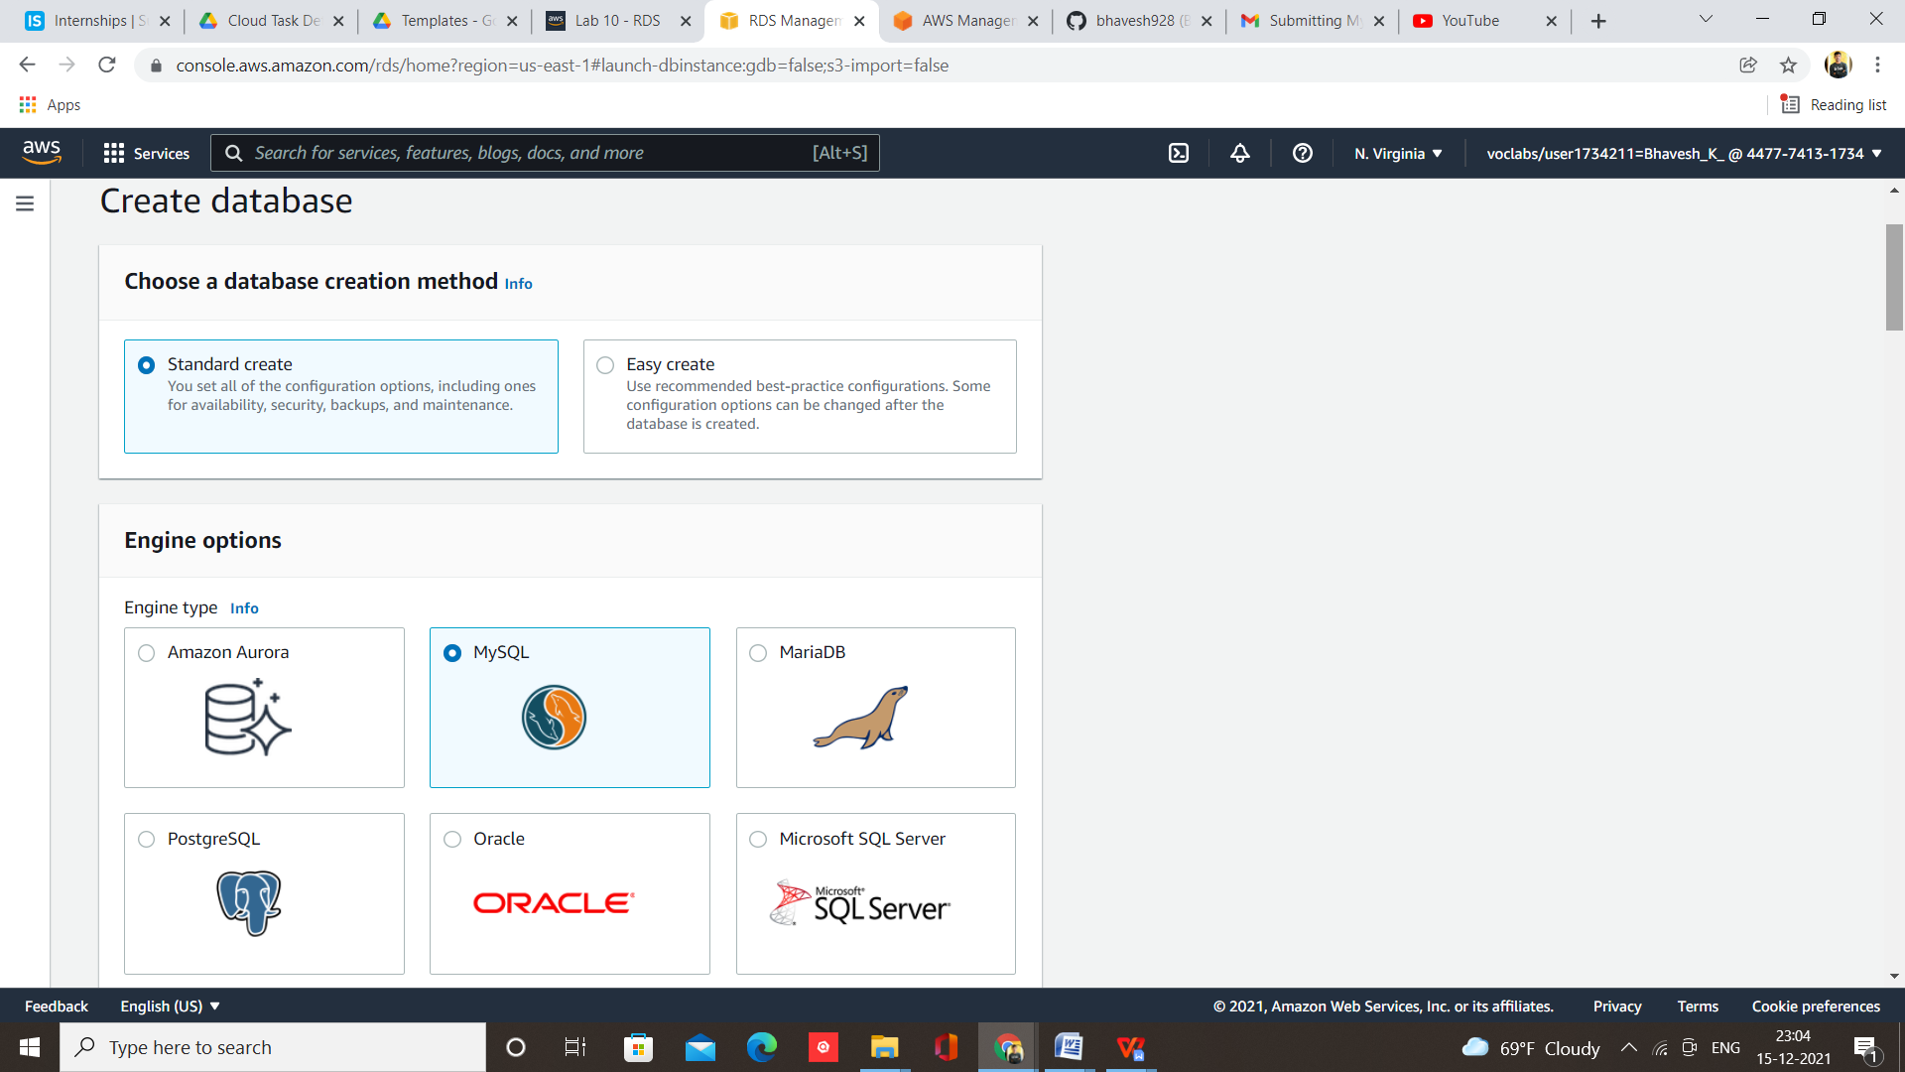

Step 6 – Give name to database and set password

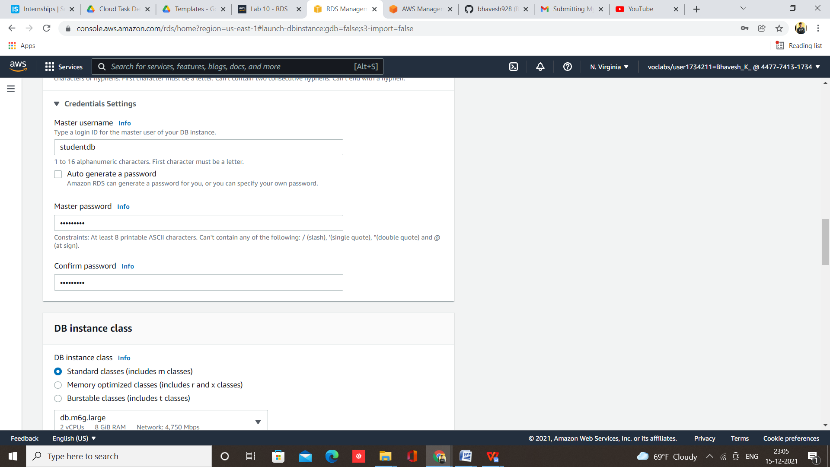

Step 7 – Click on Create Database

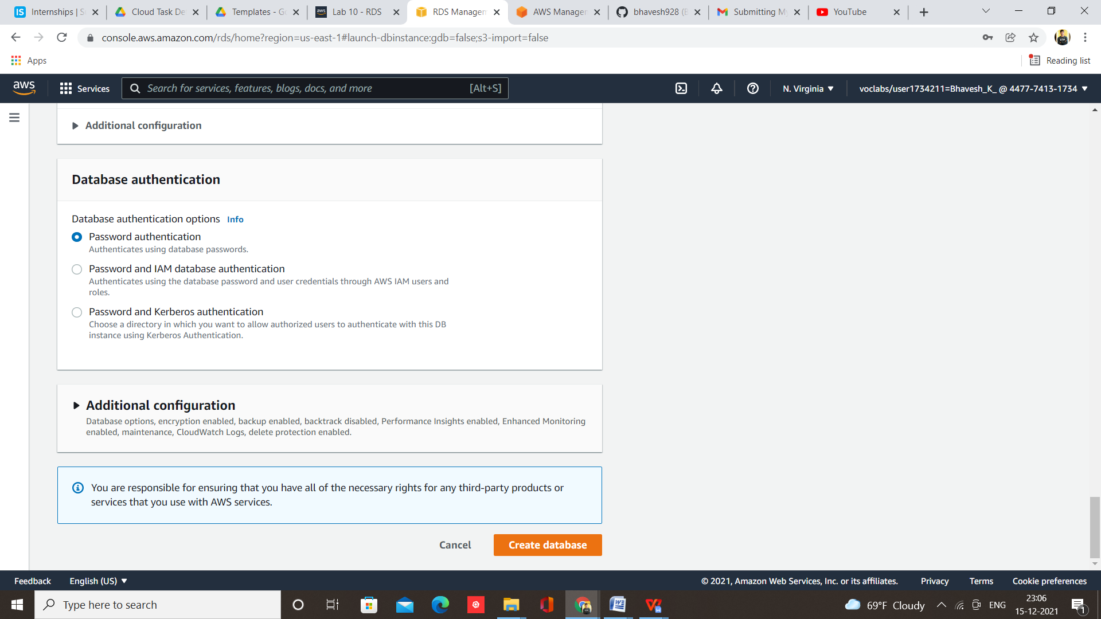

Step 8 – Now you will get Endpoint address of created database

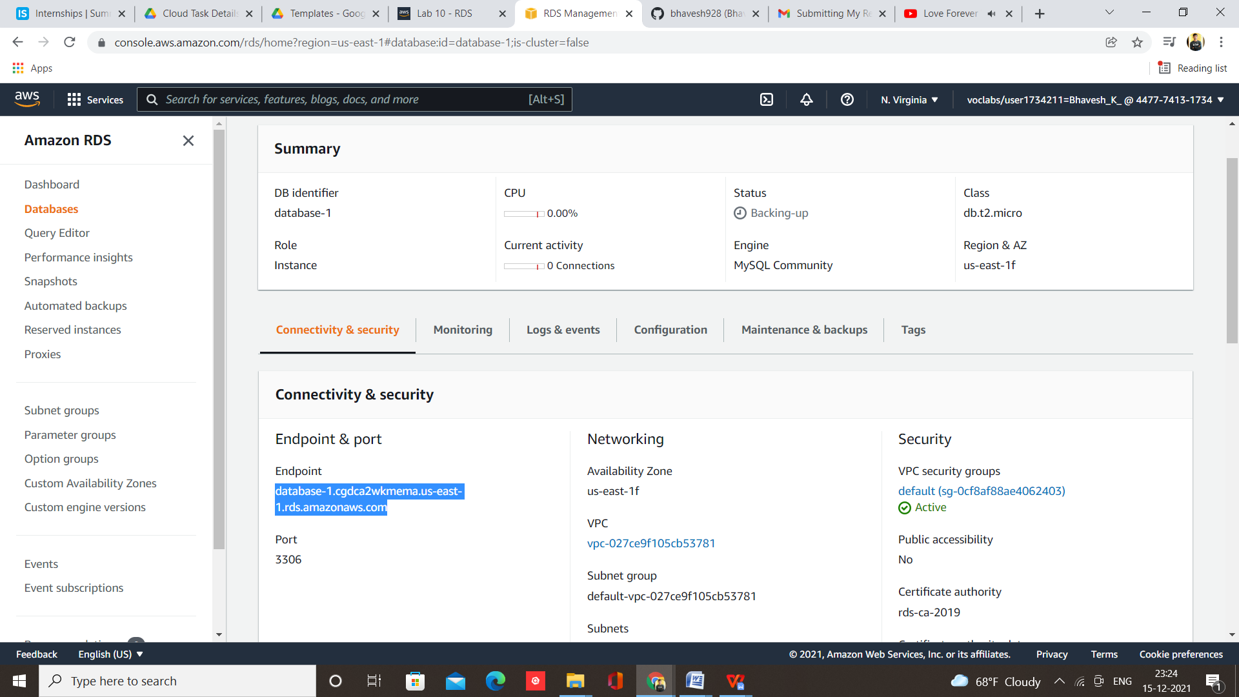

Step 9 – Now Open MySQL Workbench and paste endpoint address of database and password

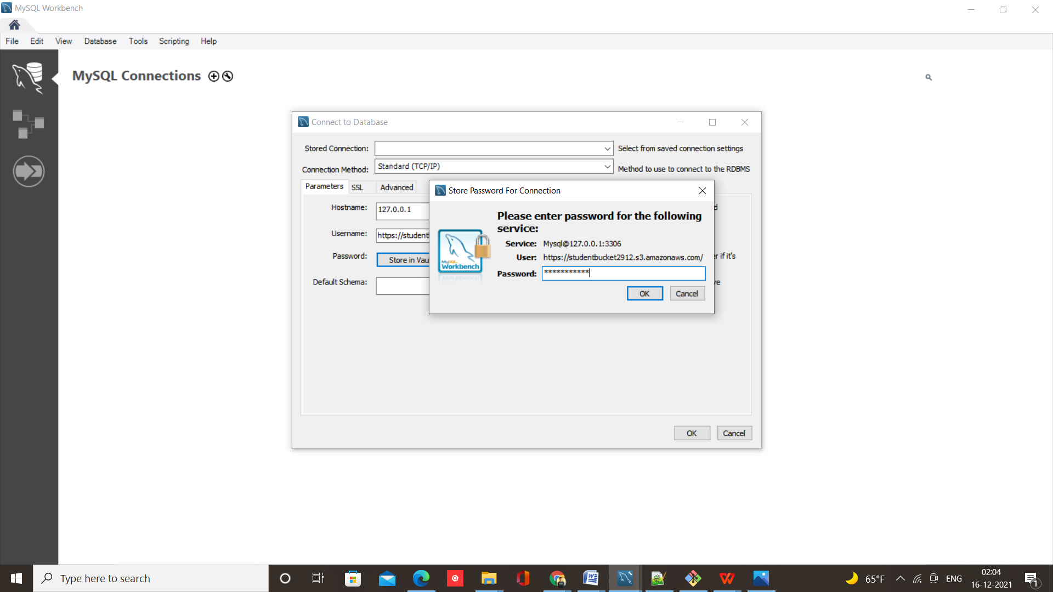

Step 10 – Database will be connecting with the MySQL Server

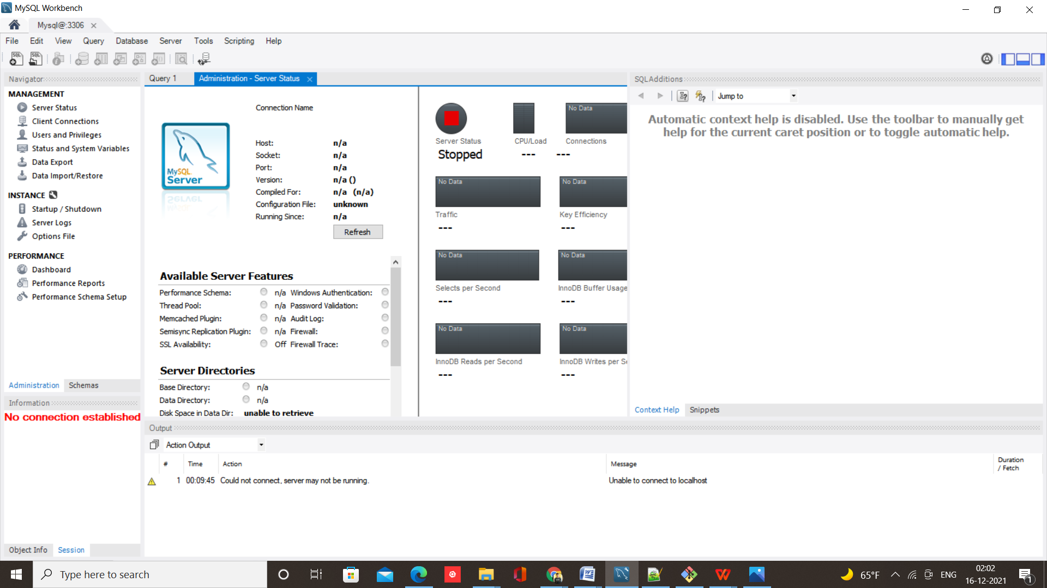

**Steps deploy webpage using Amazon S3**

Step 1- Login to AWS and select Lab 4.2 S3 and click on Start Lab

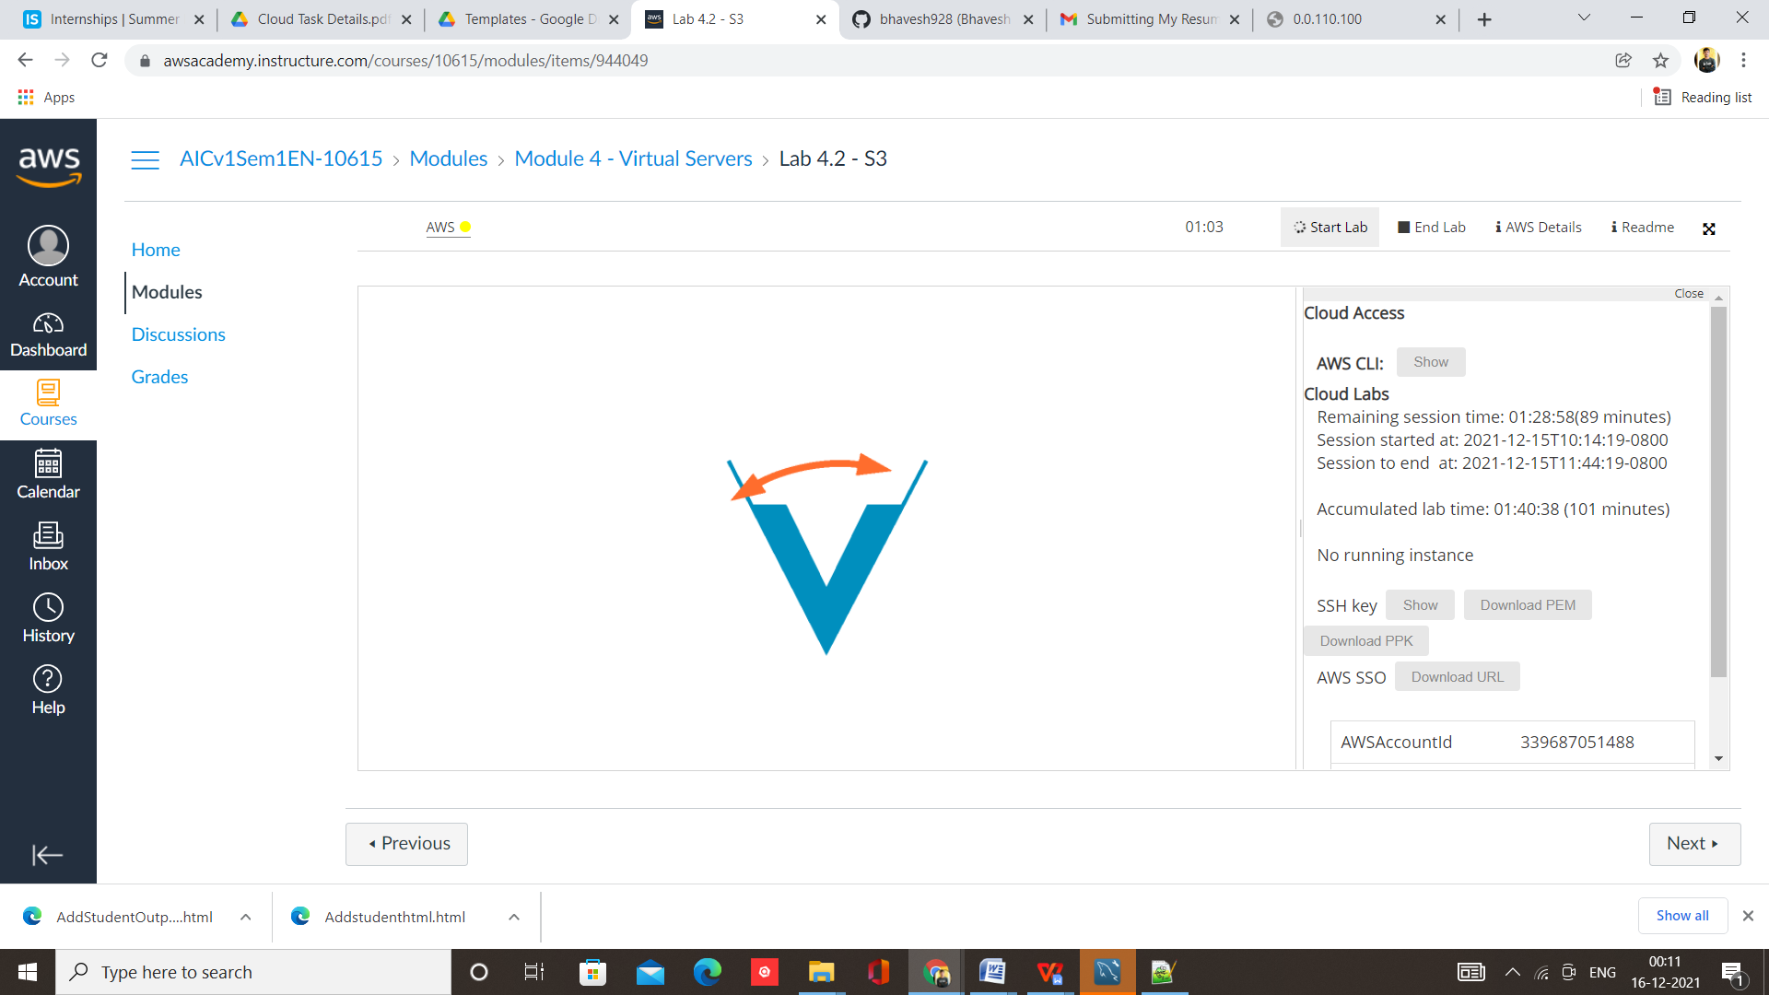

Step 2 – Select S3 from Services

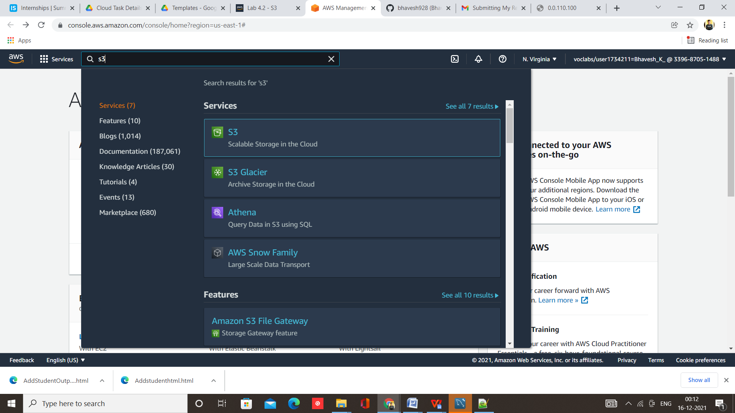

Step 3 – Click on Create Bucket

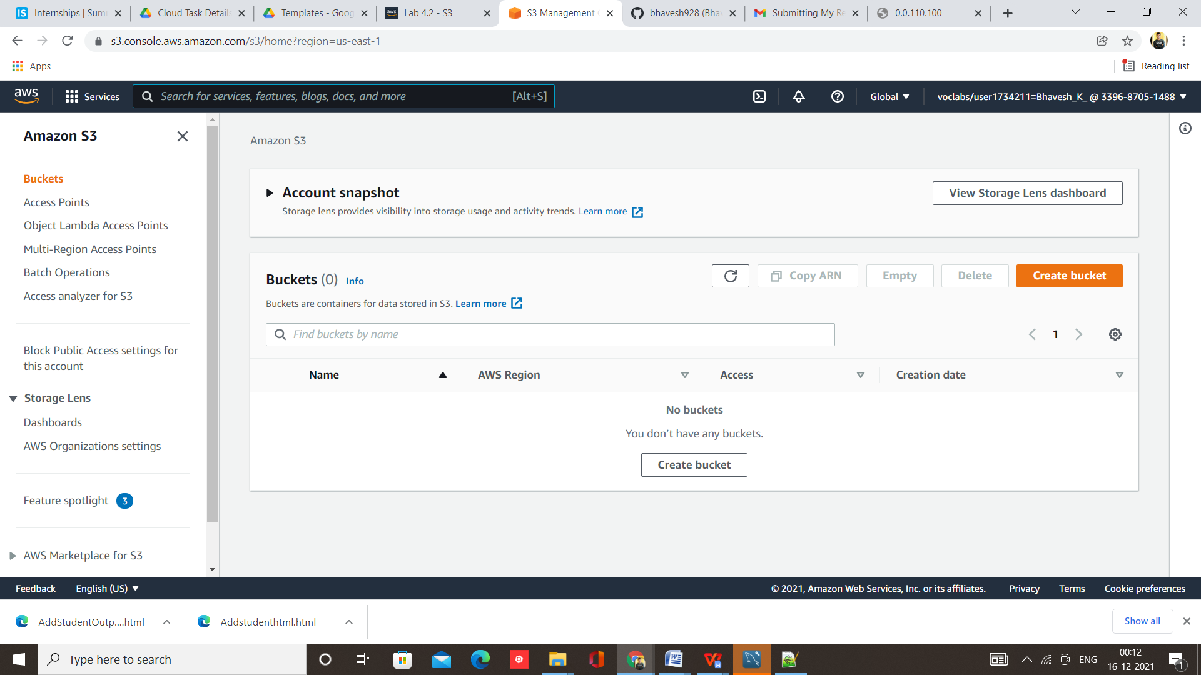

Step 4 – Give name to bucket and Make ACLs enabled

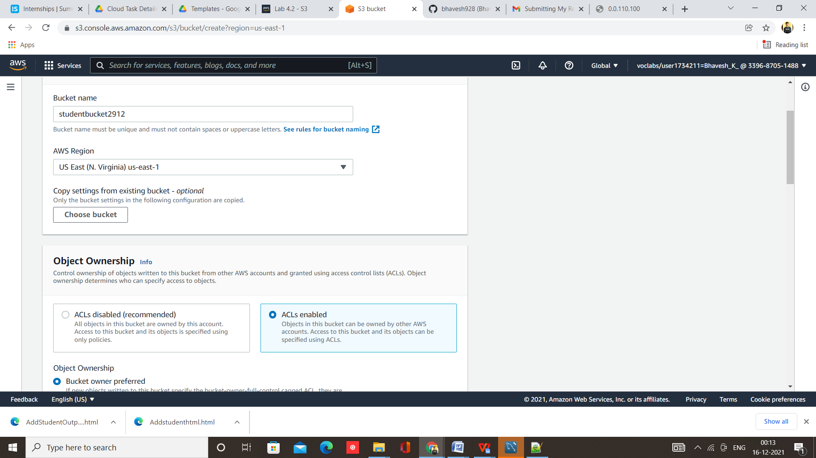

Step 5 – Click on create bucket

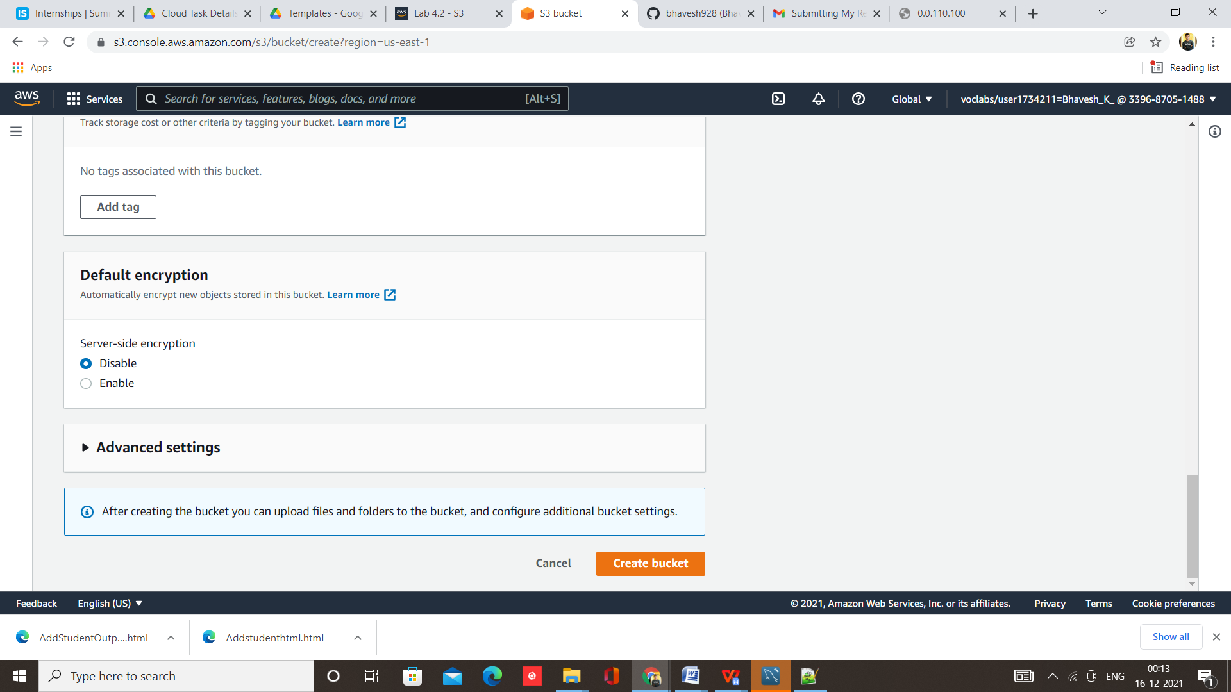

Step 6 –Bucket Created Successfully, Now open bucket

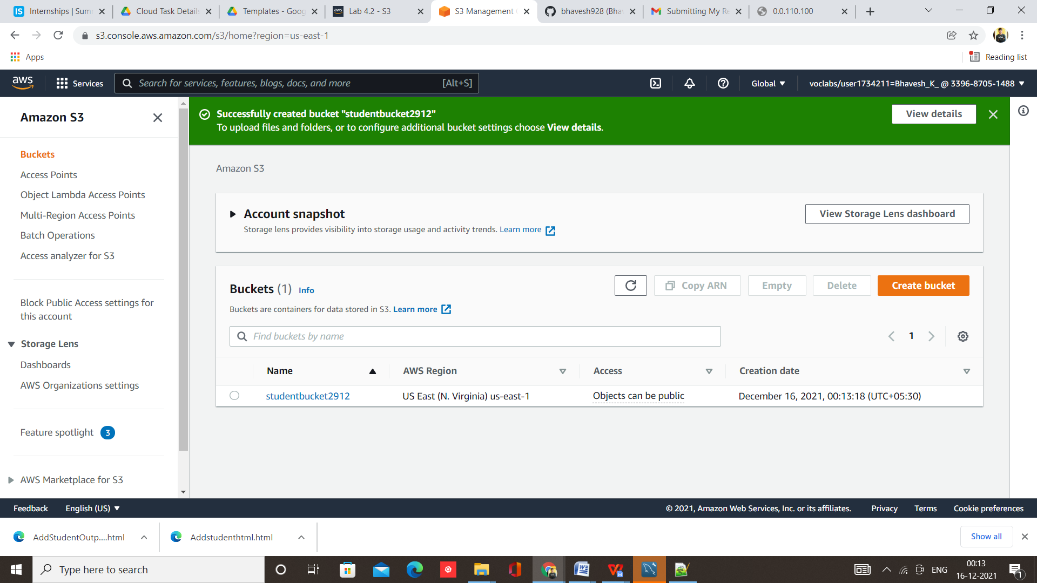

Step 7 – Upload your webpage

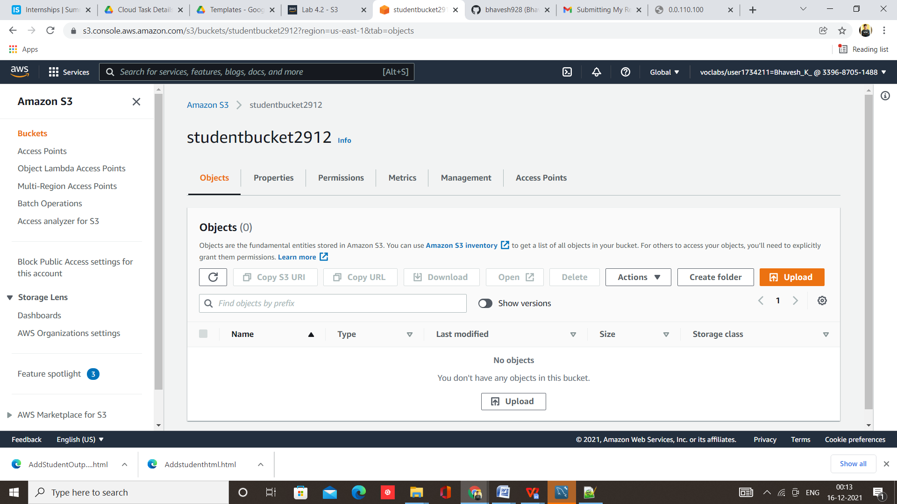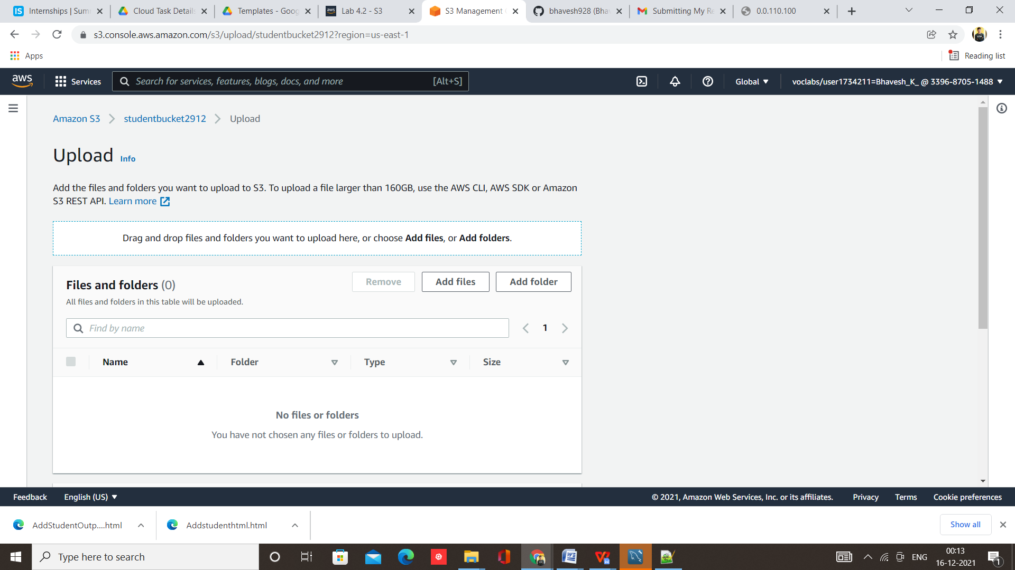

Step 8 – Webpage uploaded successfully

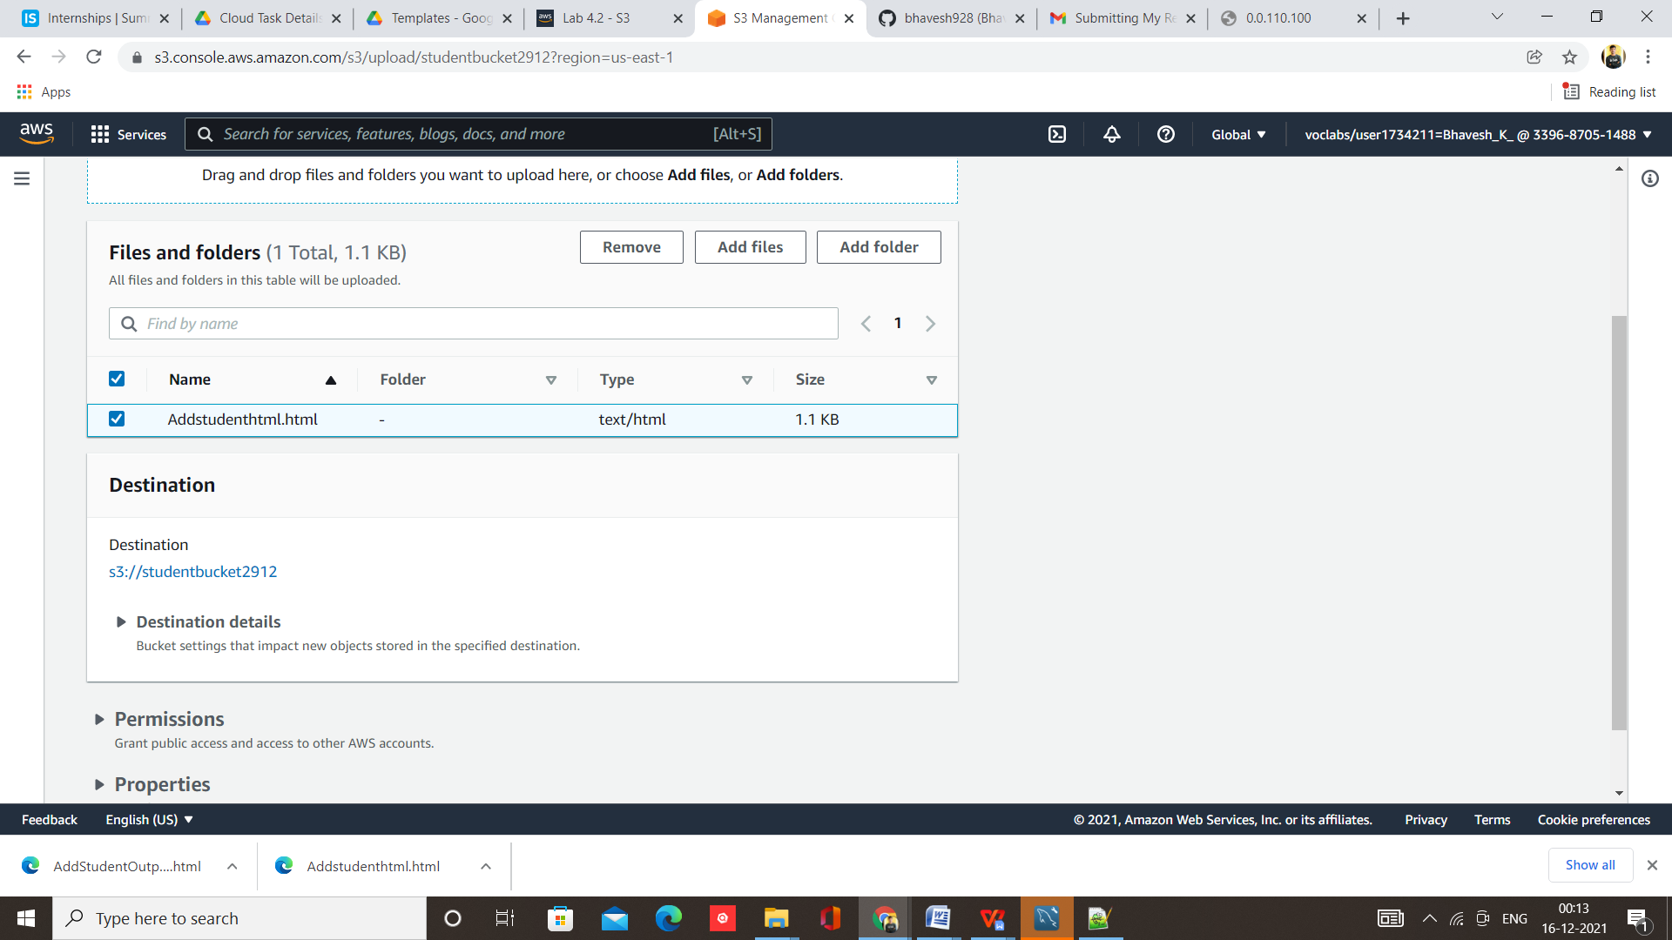

Step 9 – Click on upload

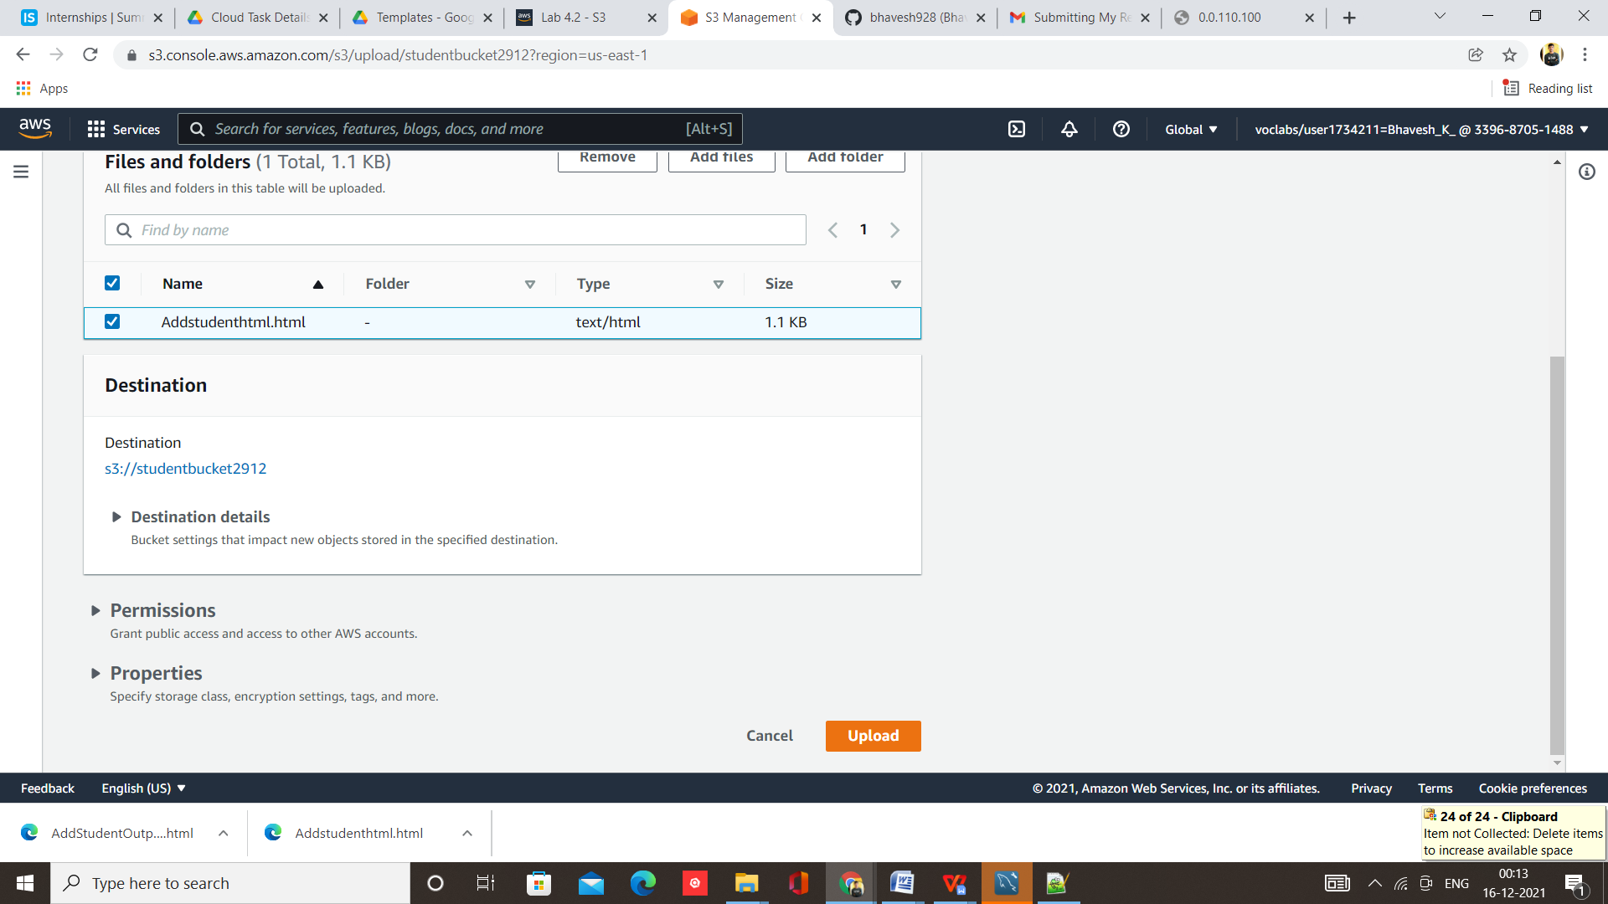

Step 10 – Upload Succeeded

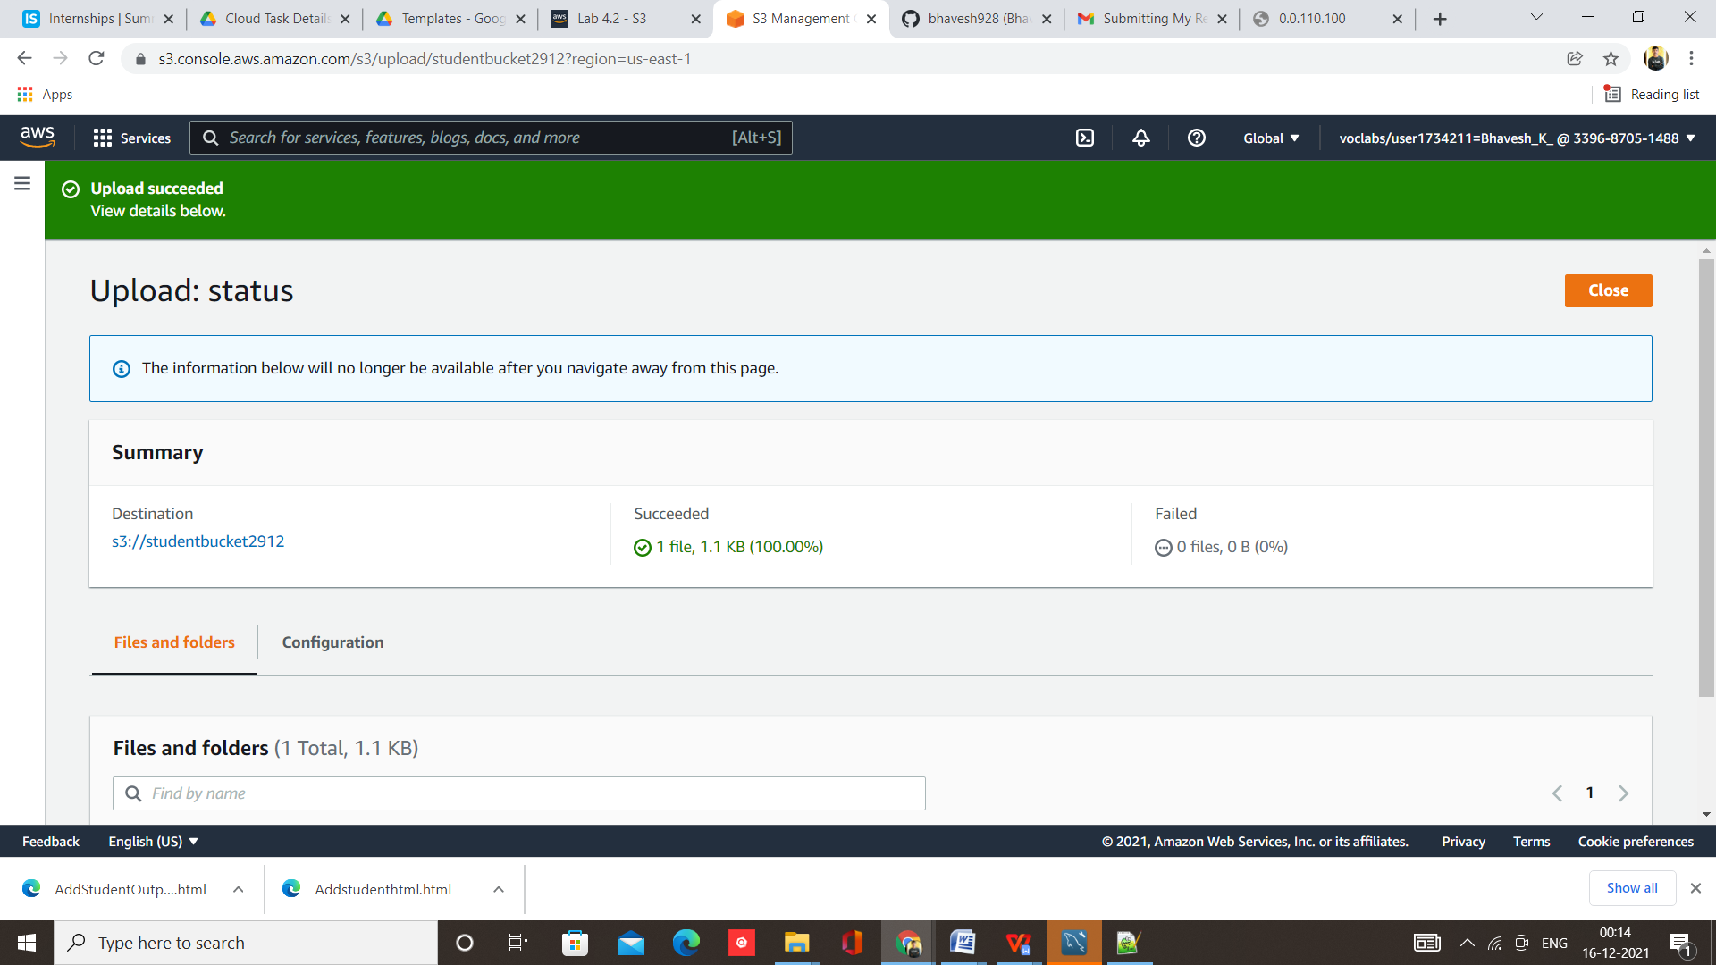

Step 11 – Make it public readable

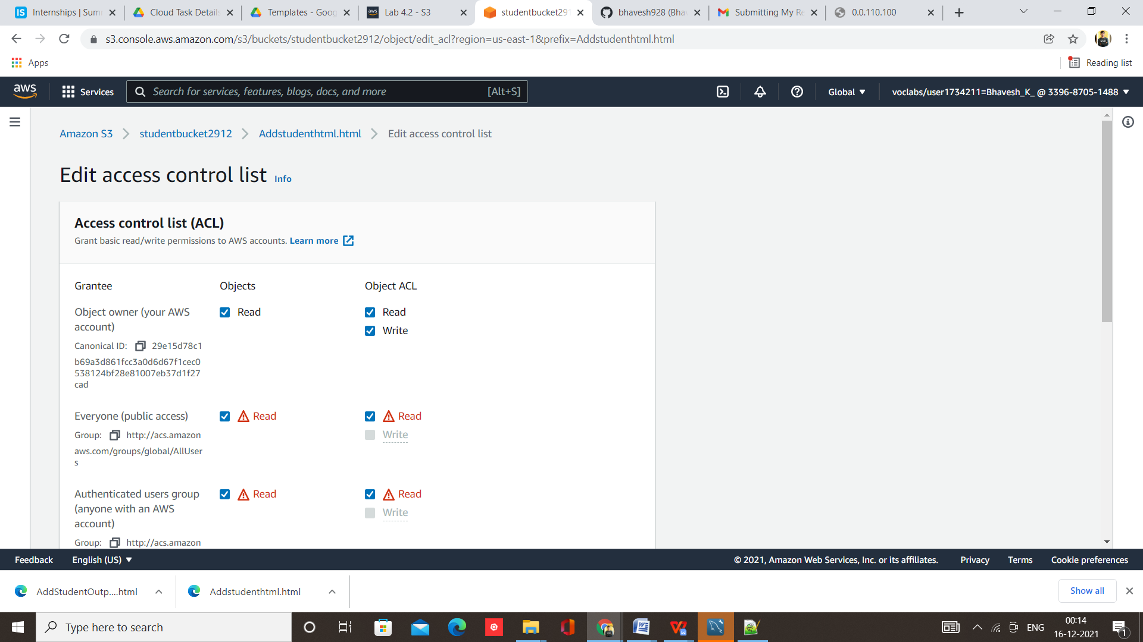

Step 12 – Save Changes

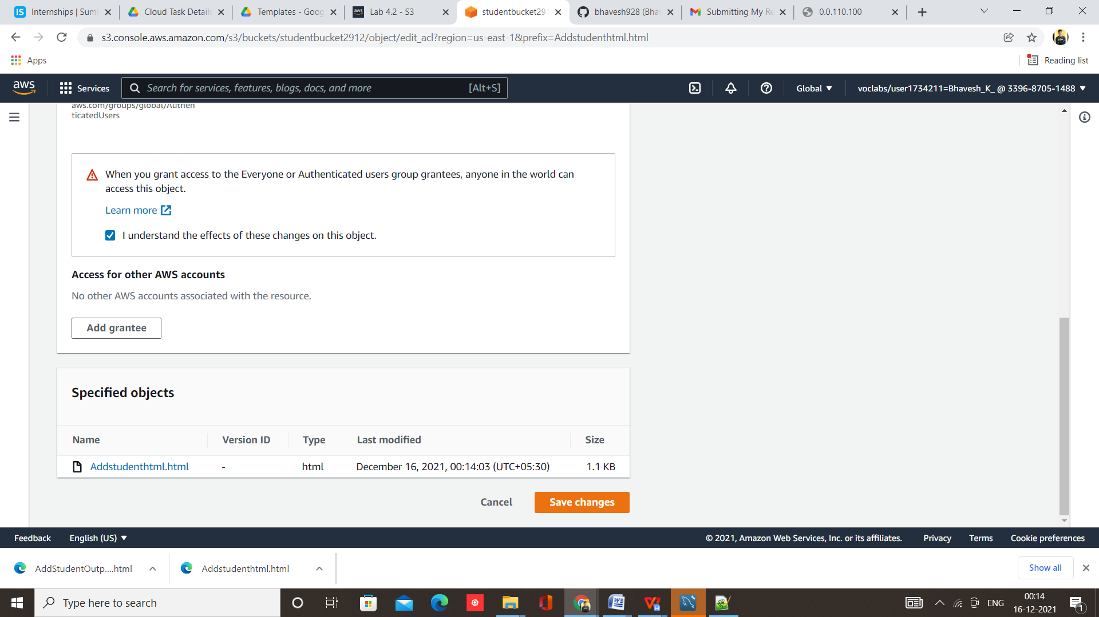

Step 13 – Now copy the object URL and paste it into browser

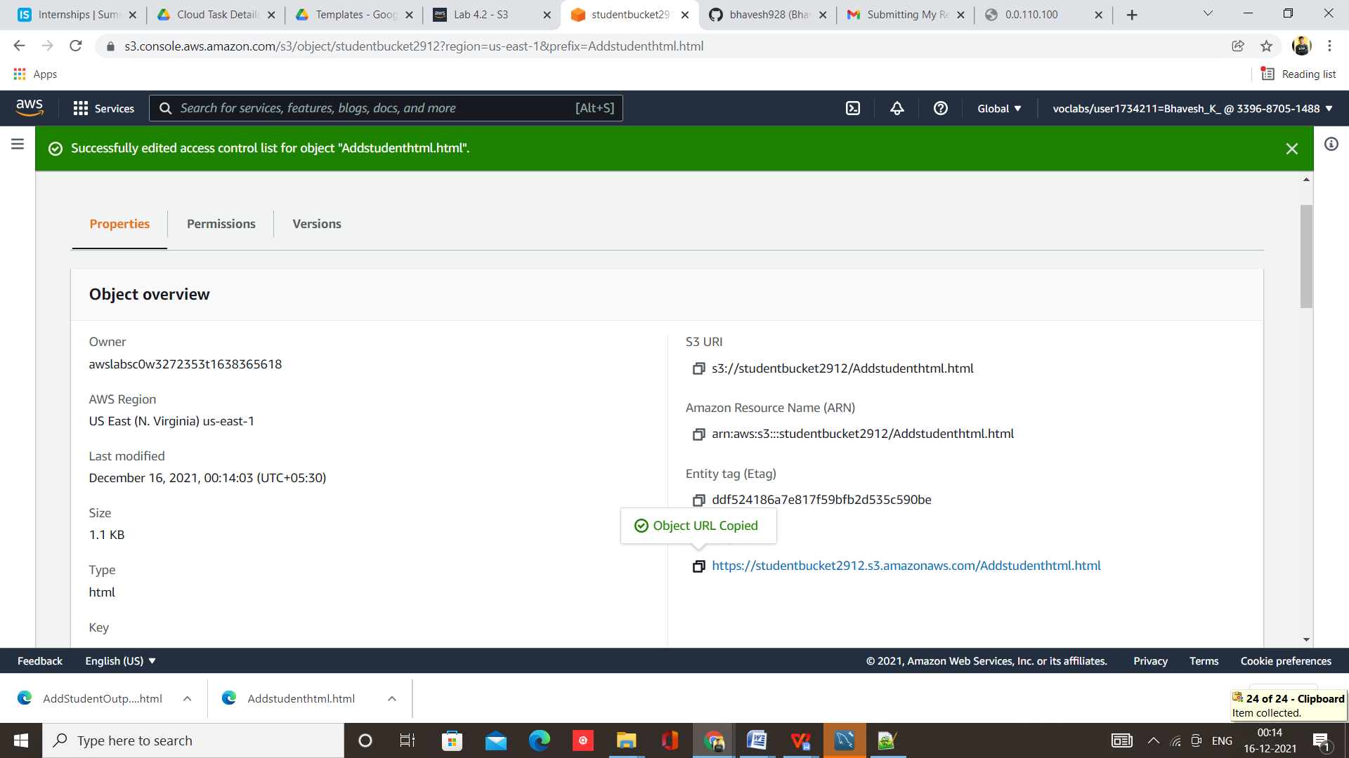

Your webpage/website is working successfully

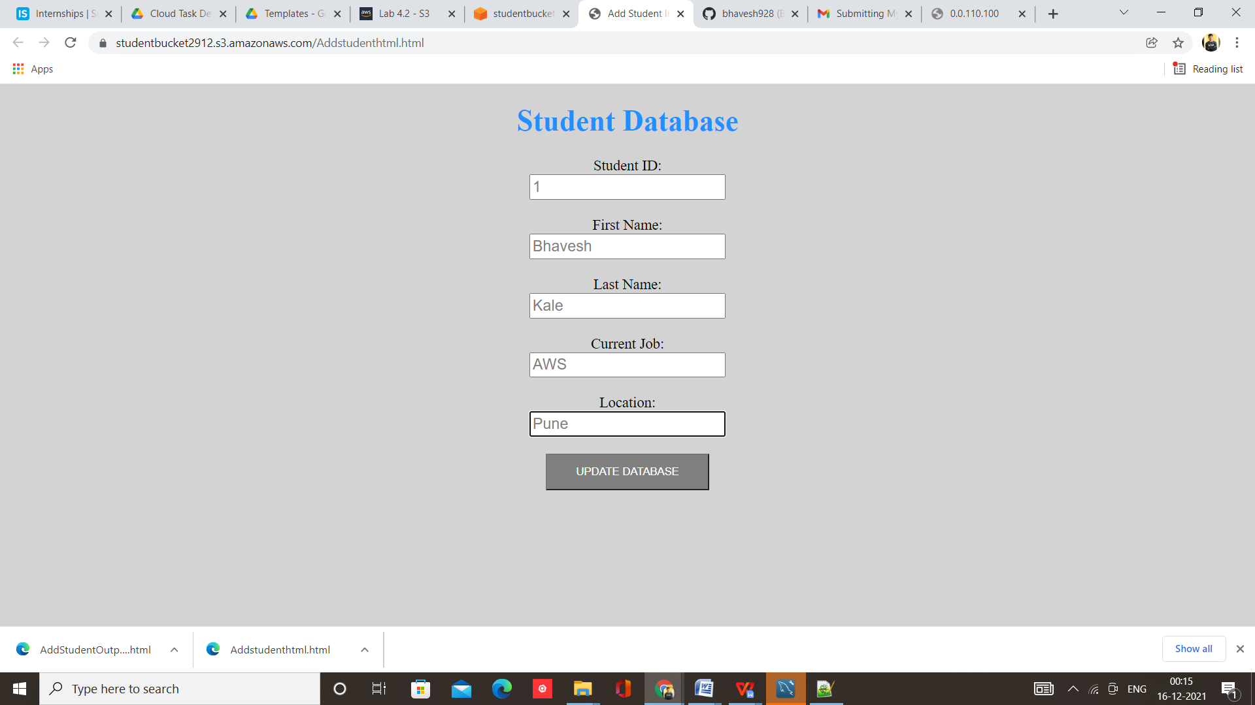

**Note –** This URL is valid for 2 hrs only as I am using AWS Student account and account is provided by college so there is certain time limit of 2 hr after that lab will be stop automatically.